WORLD FELLOWSHIP CENTER

COVID-19 OPERATIONAL SAFETY PROTOCOLS
Summer 2022 (Updated June 26, 2022)

World Fellowship Center is excited to welcome visitors and staff on-site summer 2022 in a safe and responsible manner. It is incumbent on all of us to share a responsibility in the health and safety of our spaces so our community may continue to thrive. This Safety Plan will be based upon the best knowledge and advice we have at our disposal at the date it is modified. This is a living document to be reviewed regularly and adjusted at the discretion of WFC management. Any major adjustments will be shared publicly as needed. All questions may be directed to WFC’s Covid Safety Officer, at covidsafety@worldfellowship.org.

WFC requires that all who can be vaccinated are fully vaccinated prior to arrival onsite at World Fellowship. Please send confirmation of vaccinations dates to covidsafety@worldfellowship.org at least 72 hrs prior to arrival. In addition, testing will be required, please see below for details. Note: There will be a very small percentage of people in the WFC community who are unable to be vaccinated at this time. Safety precautions will be taken to ensure as safe an environment as possible.

Special Notes:
- “Physical Distancing” means 6 ft of distance from mouth to mouth.
- “Masks” or “Masking” refers to a mask that covers both nose and mouth. WFC management encourages the use of KN95 masks as per the most current masking recommendations.
- Anyone may be asked to wear a mask at any point, either outdoors or indoors, when away from sleeping quarters. Please always carry a mask to use as necessary.

REQUIREMENTS FOR PARTICIPATING ONSITE AT WFC
- All visitors eligible for Covid-19 vaccination must be fully vaccinated prior to arrival onsite. If eligible for the booster, it is also required. Those who are unable to be vaccinated should contact covidsafety@worldfellowship.org to submit an exemption request.

- For office use and knowledge, visitors must notify WFC with date of last vaccination shot to covidsafety@worldfellowship.org at least 72 hrs in advance of arrival.
- For those taking a flight to arrive at WFC, it is recommended that you take a Covid test prior to departure as a precautionary measure.

ADDITIONAL TESTING INFORMATION
- To find more information on testing and how to test at home prior to traveling, visit the CDC Self Testing site.
- Many local clinics and pharmacies have self-tests available.
- If unvaccinated and onsite for more than 7 days, we ask visitors to test weekly.

POD ZONES FOR MEALS
- Each visitor, volunteer, and staff member is assigned a designated Pod Zone, predominantly for purposes of eating together.
- Pod Zones will be identified by a Letter (A/B/C, etc)
- Specific Pod Zones will be outlined upon arrival and any questions may be directed to the Covid Safety Officer or emailed to covidsafety@worldfellowship.org or office@worldfellowship.org.

LODGING
- Individual
  - All individual rooms are private quarters and guests may be unmasked in this room only.
  - Staff will not enter personal space without emergency cause therefore visitors will be required to clean their own room and remove trash as needed during their stay. Housekeeping will do a thorough cleaning in between visitor stays.
- Shared Spaces
  - In all general INDOOR common spaces (i.e. hallways, kitchens, Uphaus or Weller living rooms), everyone must be masked.
  - In all general OUTDOOR common spaces (i.e. Lloyd Lodge Lawn, Waterfront, etc.), people may be unmasked when more than 6 ft. apart from those in separate pods.
  - Lodging includes shared common areas and shared bathing areas. All unmasked bathroom activities (shower, tooth-brushing, etc.) must not last longer than 15 minutes.
  - In screened porches and dining hall, unmasked activities may occur with members of other pods provided 6 ft. of distance is maintained. When within 6 ft. of members from other pods, masks are required. Breezeway areas will predominantly be used for meals so pod zone differentiation will be important.

DINING
- General Plan
  - All meals will be done in a buffet style set up.
  - For all meals, visitors will be seated together by their pod zone in the dining hall, on the porch, or on the lawn, with distancing between tables. All windows will remain open and fans will be on. Tables and chairs will be distanced and limited for maximum capacity.
  - Seconds and food alternate options will be available at a pick up station. One person from each pod zone will collect all seconds and alternates for the table.
  - Everyone (visitors and staff) will wear masks when they are not seated or eating.
  - Inside the dining room, visitors will scrape and stack and leave dishes on tables for staff to retrieve. If eating on the porch or outside, staff and visitors will be asked to scrape dishes and leave them at the designated drop spot inside the dining hall.
  - Breakfast is at 8am, Lunch at 12:30pm, Dinner at 6pm. Self-Service continental breakfast will be available until 10:30am and self-service snacks will be provided throughout the day.
- Buffet Meals
  - All meals will be set in buffet bars covered with sneeze guards and sanitizer required at the front of the line.
  - Coffee and hot water will be pre-set in carafes for breakfast. Coffee will be available at the porch coffee station during the day. People may enter the porch, masked to fill their coffee.
  - Cookout will be served on the lawn in a similar buffet style.
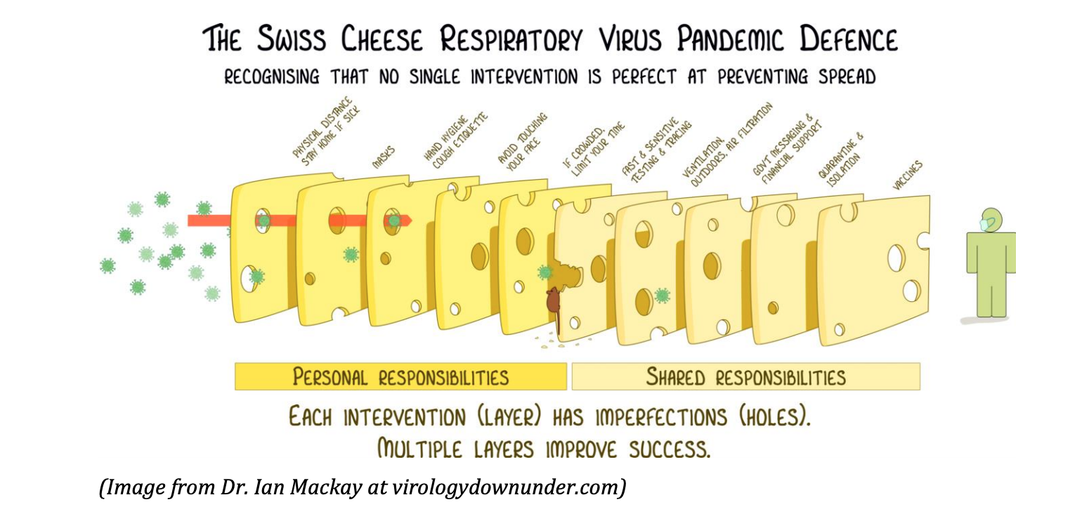

PROGRAMMING
- General programming will be held on the lawn as much as possible and all outdoor masking/unmasking parameters apply.
- When programming is indoors or in the Schmauch meeting room, masking will be required unless participants are all within the same pod.
- Additional Activities:
  - Outdoor evening activities may include campfires and lawn games. Guests are encouraged to engage with each other in spontaneous activities.
  - Access to the Lloyd Lodge porch will be available for evening activities such as puzzles and board games.
- Any recreational activities led by WFC Staff require the same protocols as onsite activities.
  - Masking will be required when indoors with anyone from another podzone and if one is within six feet of someone from another pod zone out of doors.
- Children’s Fellowship will be offered 6 days per week for children ages 3-12, please contact reservations@worldfellowship.org for details if you intend to enroll your child.

OFFICE
- Covid testing will be conducted away from the Main Office at a designated location. Please pay attention to communications from reservations@worldfellowship.org and covidsafety@worldfellowship.org for testing details upon your arrival.
- Lloyd Lodge Office will be open daily with limited hours. All those working inside the office and visiting the office are required to wear masks.

DAY VISITORS
- All day visitors who wish to engage in indoor activities are required to be vaccinated and should email covidsafety@worldfellowship.org with proof of vaccination. Additionally, day visitors should plan to take a rapid test prior to arriving or upon arrival at WFC. If taking the test prior, email covidsafety@worldfellowship.org with test results to get on the approved list.
- Any day visitors who have not registered and/or do not receive a covid-19 test are welcome to join WFC guests outdoors, masked, and distanced. Untested day visitors will have access to a restroom on the terrace level at Lloyd Lodge. We ask that visitors respect the WFC covid safety policies and do not go indoors other than use of this restroom.

